**Project Name:** ${projectName}

**Location:** From ${locationFrom} To ${locationTo}

**Performed by:** ${performedBy}

**Test Type:** ${testType | getValue:””}

[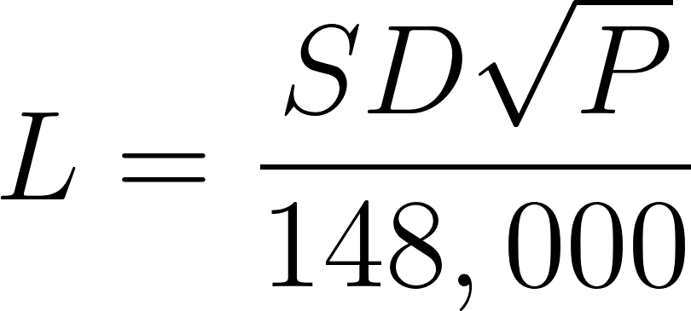](https://www.codecogs.com/eqnedit.php?latex=L%20%3D%20%5Cfrac%7BSD%5Csqrt%7BP%7D%7D%7B148%2C000%7D#0)

L = Quantity of makeup water / Testing leak allowance (gal/hr)

S = Length of pipe section being tested (ft)

D = Nominal diameter of pipe (in)

P = Average test pressure during the hydrostatic test (psi)

S = ${sValue} D = ${dValue} P = ${pValue}

**Start Time:** ${startTime} => **Pressure:** ${pValueStart} psi

**End Time:** ${endTime} => **Pressure:** ${pValueEnd} psi

**Pressure Loss:** ${pValueLoss} psi

L = ${lValue} (gal / hr)

**Observed by:** ${inspectorName}

**Test Results & Comments:** ${testResult}

${testComments}

**Signature:** ${signature | getValue:"" | size:300:0} **Date:** ${inspectDate}